Processing Timecards – Editors

This document is intended for use by designated timecard reviewers. The purpose of this document is to provide instruction on how to move time (daily) from Unverified to Processed for the previous workday.
Once logged into the ERP system, you should navigate to the ERP entry point ‘Clock Punch Verification’.
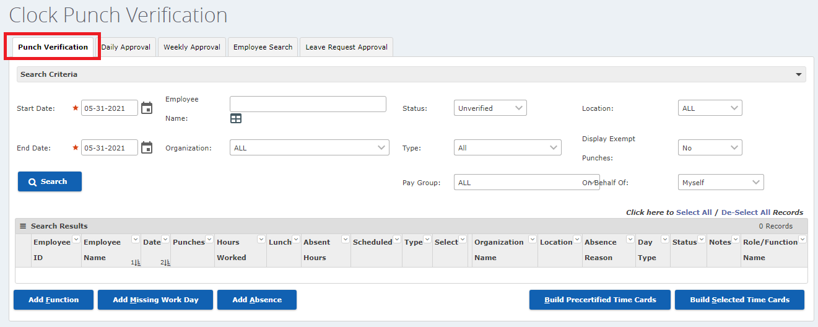

- On the Punch Verification tab, enter the date for the timecards you are building and Status = Unverified.
- When you have finished configuring the criteria, click Search to display matching records.

Always check and correct timecards for accuracy before Building Timecards.
- Review for expected morning, lunch (in and out if needed) and afternoon punches.
- Verify that lunch deductions are correct – if an employee is taking a half day, ERP will still deduct the default lunch amount from the day unless you update the lunch deduction.
NOTE: If no lunch is to be deducted, the field must be updated to Zero (0).

- Click the button to build all timecards displayed in the Search Results grid.
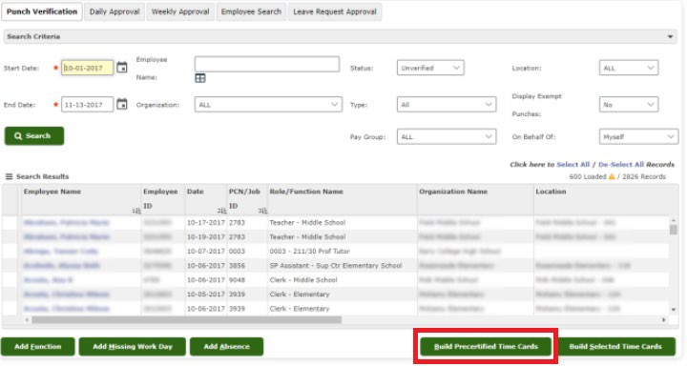

NOTE: The Build Precertified Timecard process will automatically build timecards for any records that are no more than 30 minutes greater than or less than the employee's scheduled hours.
After you have built the precertified timecards, the Punch Verification tab shows only the records that could not be processed in the list of search results.
- Review the remaining records in your list, and for each record you deem to be correct, select the Select box. If a record shows “Error” in the Hours Worked column, the Select box is grayed out and cannot be chosen.

When you have finished reviewing and selecting records, click the button. The system will process the records you selected that do not exceed the employees scheduled hours by more than two hours.
For example, an employee scheduled for 8 hours that worked more than 10 hours in a day would have exceeded the 2 hour ‘approval hours threshold’, so their timecard would not be built.

- If there are timecards that cannot be processed using the Build Precertified Timecards and the Build Selected Timecards buttons, you must review their punch details and build the timecard manually.

  - To access the Punch Verification view tab for an employee, click on the employee’s name.
  - Correct errors by adding or removing punches, adding or removing lunches, correcting times or dates on the punch record or voiding punch records entirely.
  - Click ‘Build Time Card’.

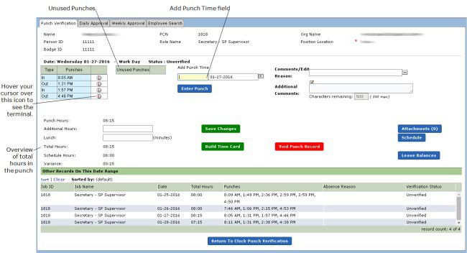

Punches: Displays time clocked in and/or out.
Unused Punches: Displays unused punches (not calculated on timecard)
NOTE: You can click and drag punches between #1 and #2. Before you release your mouse button, be sure that your cursor is touching the header row for the Unused Punches column.

Add Punch Time: Enter missing punch time and click the button.
NOTE: You do not need to type AM or PM. 4p will record as 4:00 PM. If you add a time that is not correct, click and drag to the Unused Punches.
Comments/ Attachments: Select the reason for the change. The drop down contains pre- defined Edit Reasons. Enter any Additional Comments. This is a free-text field. Attachments can also be added to the record. (ex. Doctor’s note, jury duty notice)
Lunch: The deduction for lunch comes from the employee's schedule, but the value (in minutes) can be modified here.
Schedule: Display the employee’s schedule
Leave Balances: Displays the employee's available leave balances as of the last payroll run. This information cannot be edited from Clock Punch Verification.

Void Punch Record: If for some reason the verification record was entered in error or will not be used, the record can be set as Void, which makes it inactive.
NOTE: If you void a record in error, you can retrieve (reactivate) the record.
Reactivate: On the Punch Verification screen / tab, search for the Status “Void,” double click on the employee record, make changes (if needed), and click Save Changes.
Save Changes
Build Timecard: If you have completed your changes to the record and are ready to build the Timecard, click the Build Timecard button. This action will build the timecard and set this verification record's status to Processed.

Be sure to always add notes and/or attachments to support any changes you make to employee records!

- Look for missing timecards
  - On the Clock Punch Verification page select Missing Dates in the status field and click Search.
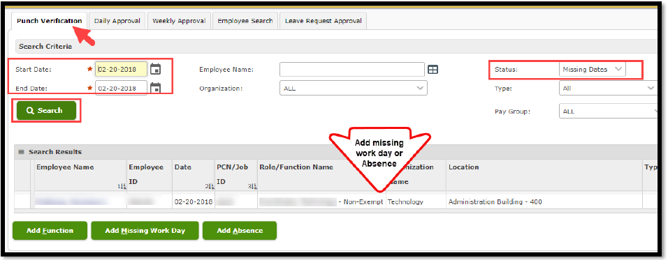
  - Use the Add Function or Missing Work Days through the buttons on the Clock Punch Verification page.
  - Missing Absences will need to be added through the Absence Management System NOTE: All non-exempt employees must have an absence or punches for each calendar day.

